Multi-site Hosting with Application Gateway (Azure Portal GUI)

Step 1 – Create Resource Group
- Go to Azure Portal → Resource groups → Create.
- Name → studentname-rg
- Region → East US (or your preferred region)
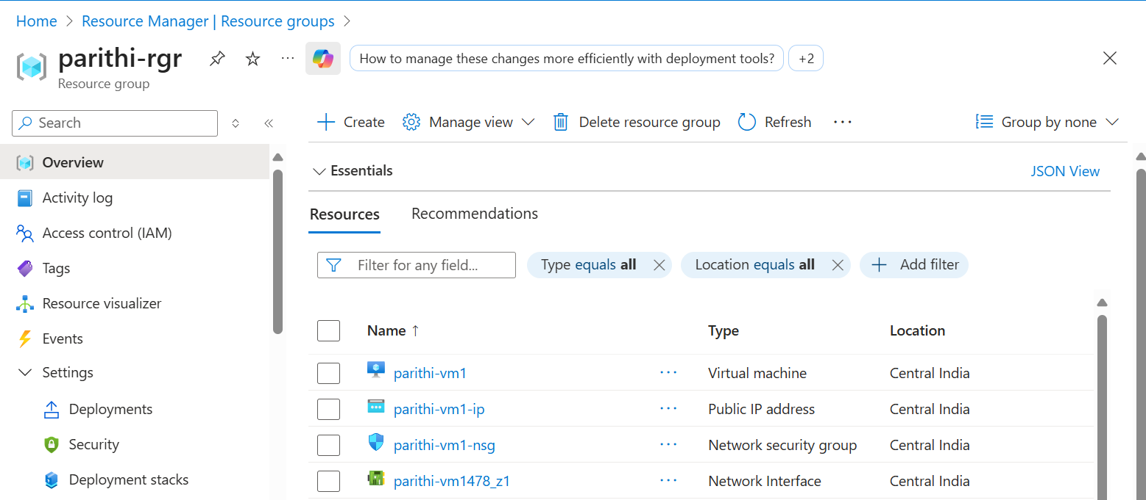
- Click Review + Create → Create

Step 2 – Create Virtual Network
- Go to Virtual networks → Create.
- Name → studentname-vnet
- Resource group → studentname-rg
- Address space → 10.0.0.0/16
- Add a Subnet:
  - vm-subnet → 10.0.1.0/24
- Add another Subnet (for Application Gateway):
  - appgw-subnet → 10.0.2.0/24
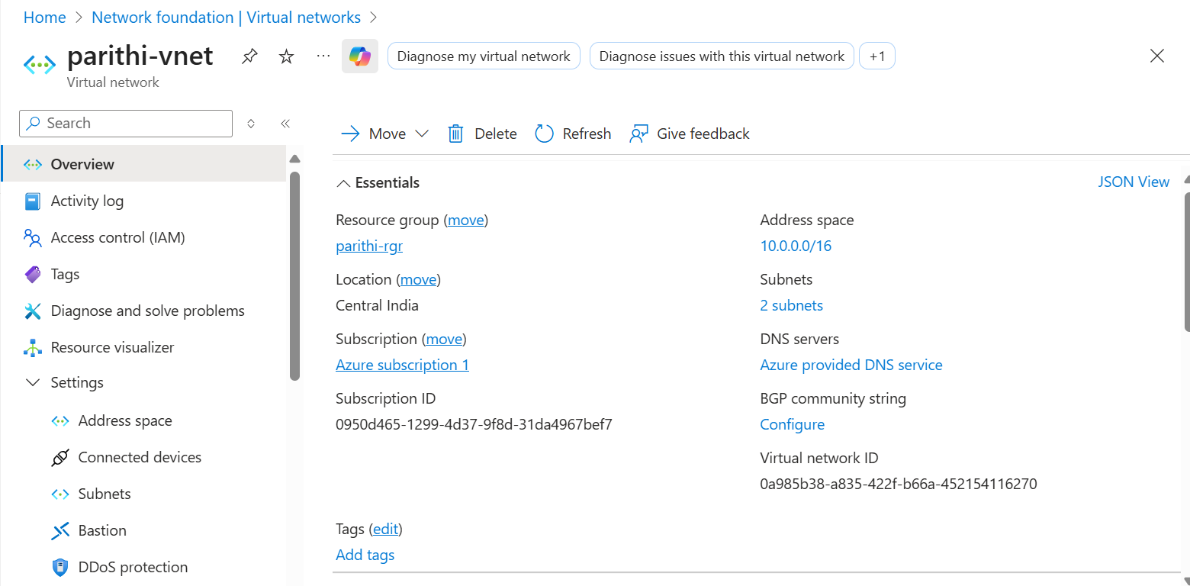
- Click Review + Create → Create

Step 3 – Create Two Linux VMs
Repeat these steps twice (for studentname-vm1 and studentname-vm2):
- Go to Virtual machines → Create.
- Name → studentname-vm1 (and then studentname-vm2)
- Resource group → studentname-rg
- Image → Ubuntu Server 22.04 LTS
- Authentication → SSH key or Password
- Networking:
  - Select studentname-vnet
  - Subnet: vm-subnet
  - Public IP: Enable (for initial testing)
  - Allow port 22 (SSH) and port 80 (HTTP)
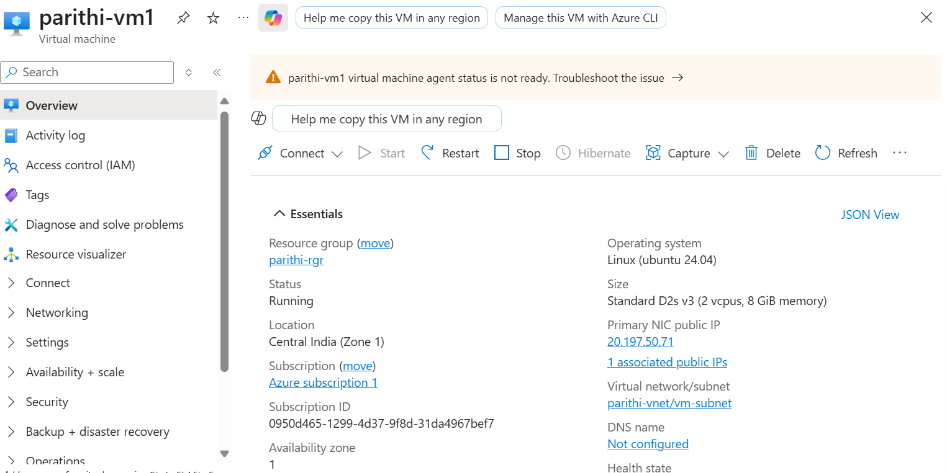
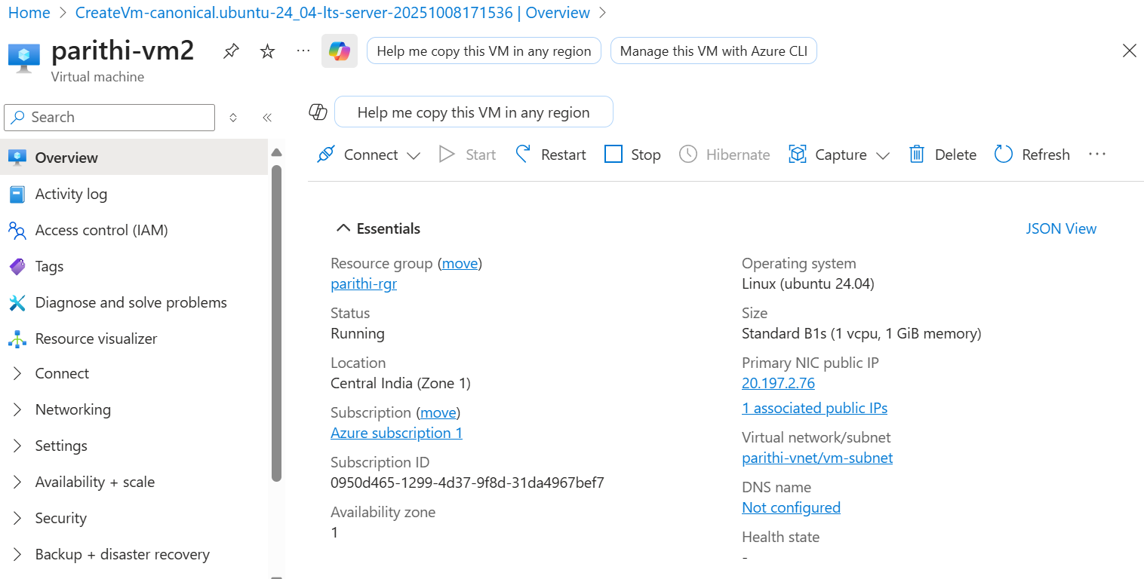
- Review + Create → Create

Step 4 – Install Apache & HTML
SSH into both VMs (via their Public IPs) and run:
On studentname-vm1
sudo apt update -y
sudo apt install apache2 -y
echo "<h1>Website 1 - studentname-vm1</h1>" | sudo tee /var/www/html/index.html
sudo systemctl enable --now apache2
On studentname-vm2
sudo apt update -y
sudo apt install apache2 -y
echo "<h1>Website 2 - studentname-vm2</h1>" | sudo tee /var/www/html/index.html
sudo systemctl enable --now apache2
✅ Test in browser:
- http://<vm1-public-ip>
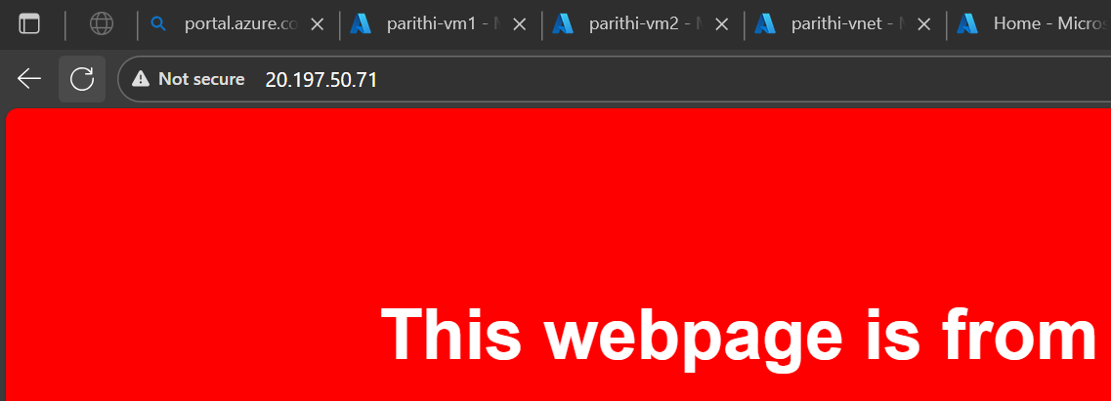
- http://<vm2-public-ip>
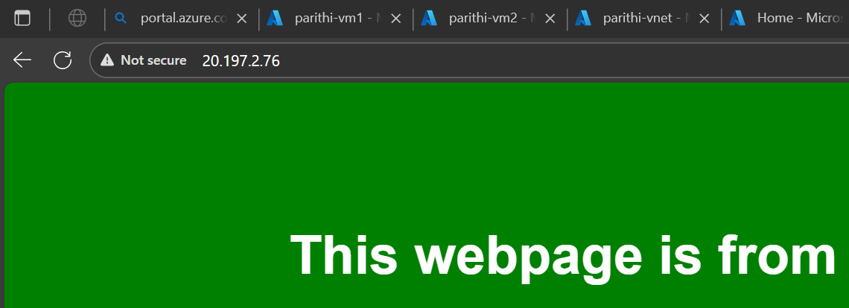

Step 5 – Create Application Gateway
- Go to Application Gateways → Create.
- Name → studentname-appgw
- Resource group → studentname-rg
- Region → Same as VMs
- Tier → Standard v2
- Virtual network → studentname-vnet
- Subnet → appgw-subnet
- Frontend Public IP → Create new → studentname-appgw-pip
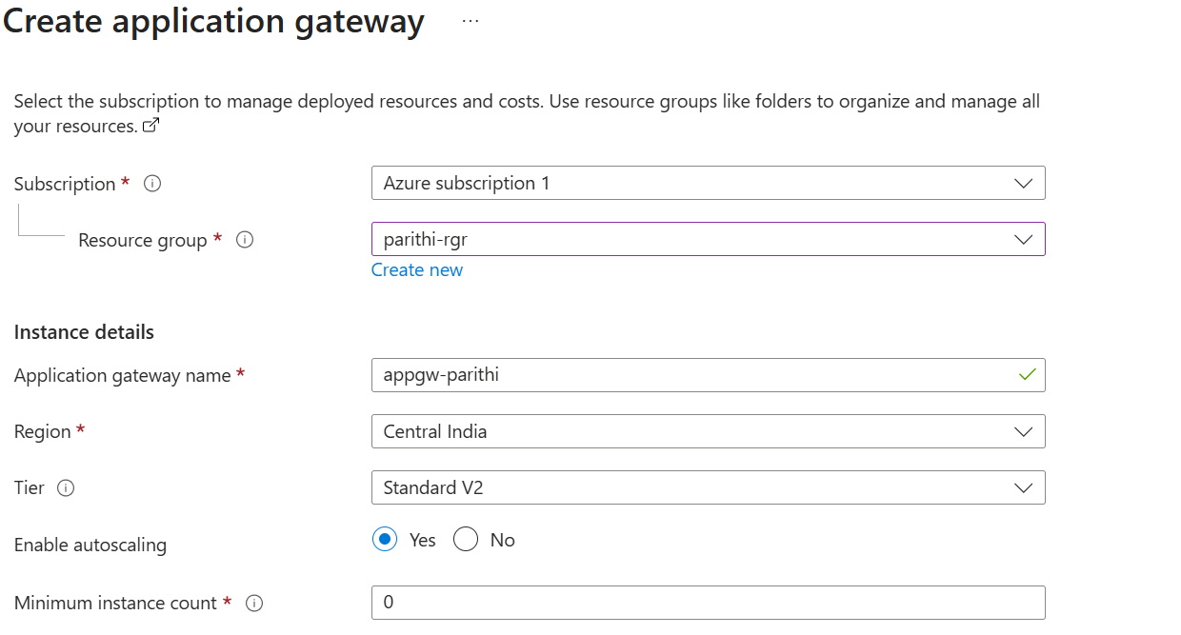
- Click Review + Create → Create

Step 6 – Configure Backend Pools
- Open studentname-appgw → Backend pools → Add
  - Name: backendpool-vm1
  - Target: Virtual machine → Select studentname-vm1
  - Save
- Add another pool:
  - Name: backendpool-vm2
  - Target: Virtual machine → Select studentname-vm2
  - Save
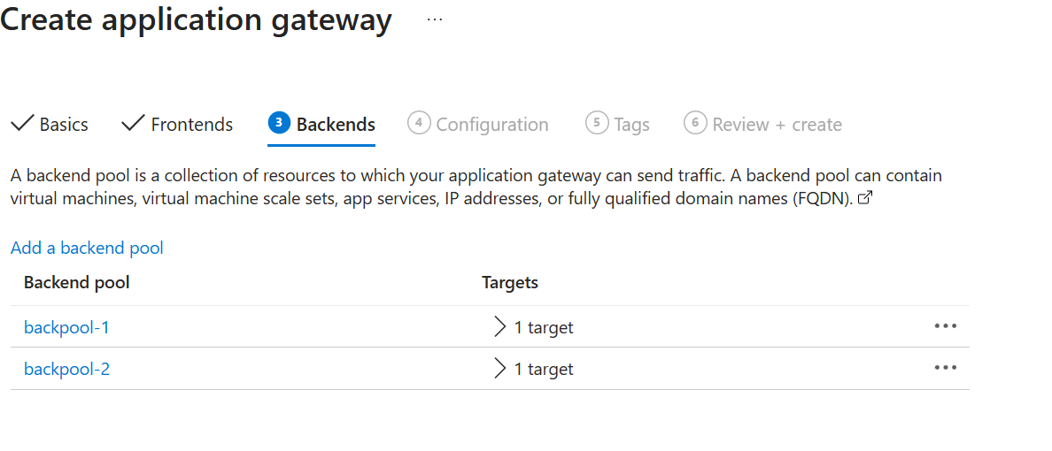

Step 7 – Configure Backend HTTP Settings
- Go to Backend settings → Add
  - Name: setting-vm1
  - Protocol: HTTP
  - Port: 80
  - Save
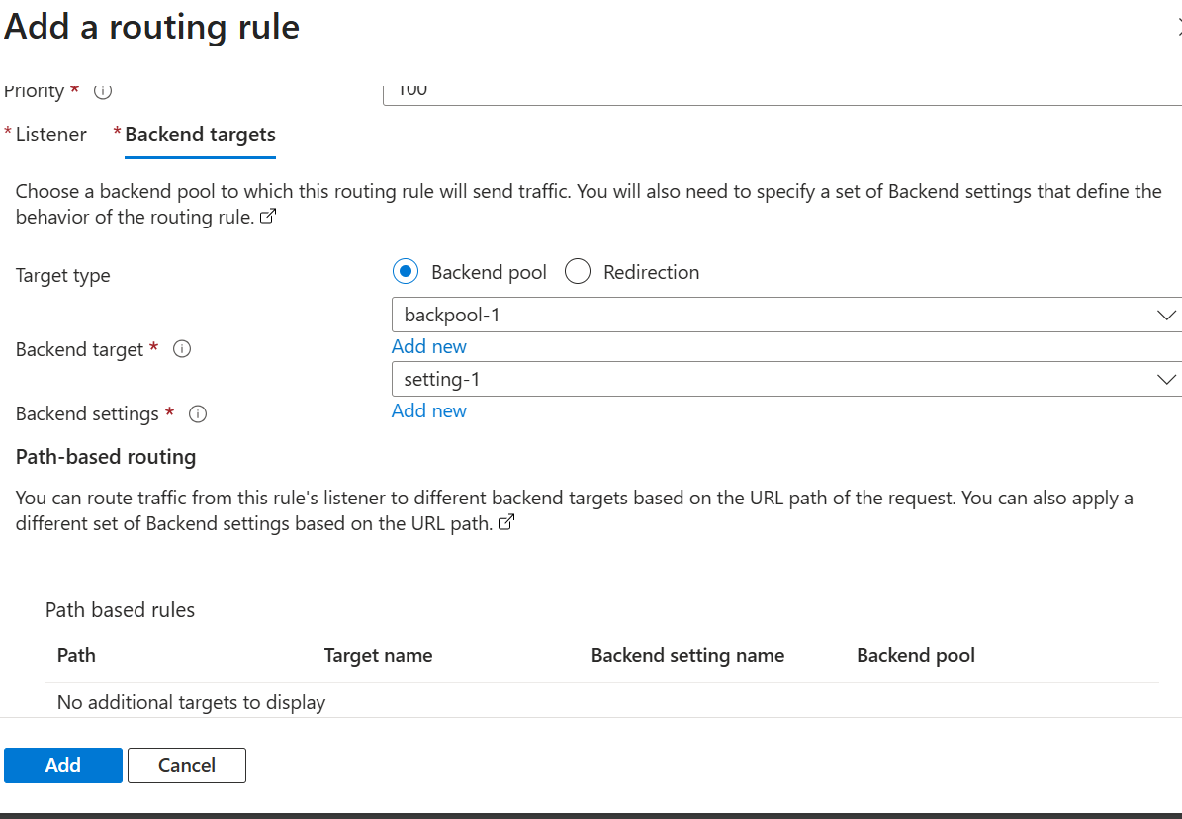
- Add another:
  - Name: setting-vm2
  - Protocol: HTTP
  - Port: 80
  - Save
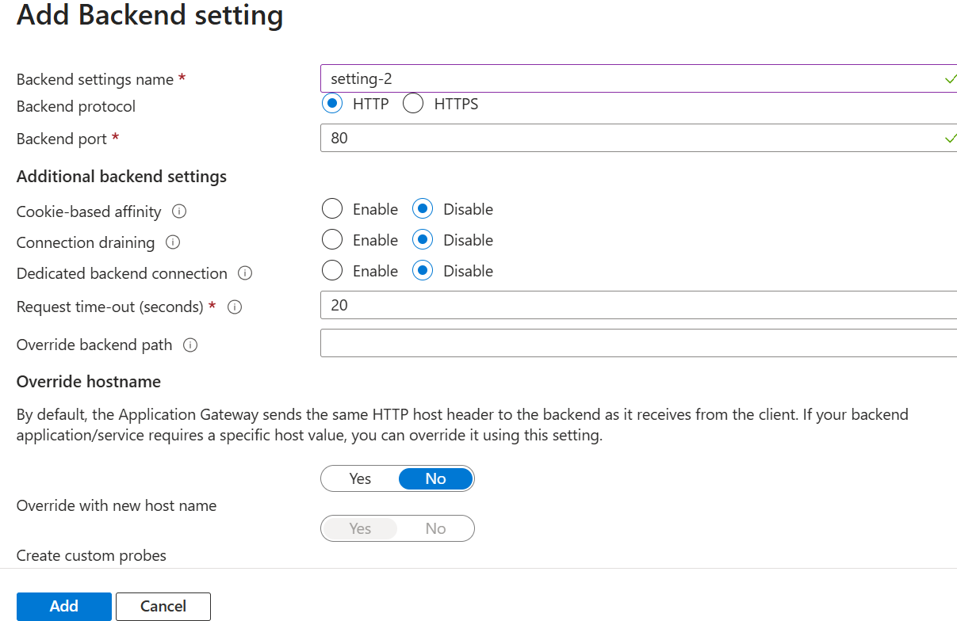

Step 8 – Configure Listeners (for Multi-site Hosting)
- Go to Listeners → Add listener
  - Name: listener-site1
  - Frontend IP: Public
  - Frontend port: 80
  - Listener type: Multi-site
  - Hostname: site1.studentname.com
  - Save
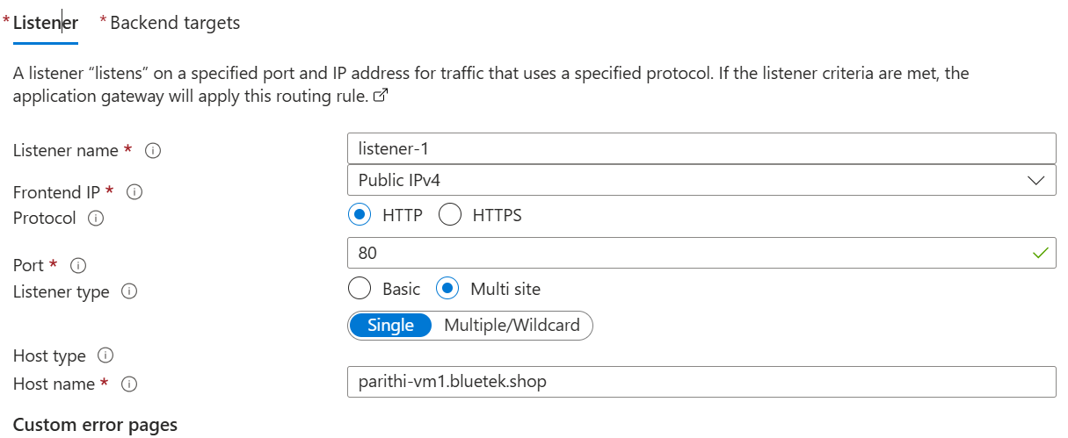
- Add second listener:
  - Name: listener-site2
  - Hostname: site2.studentname.com
  - Save
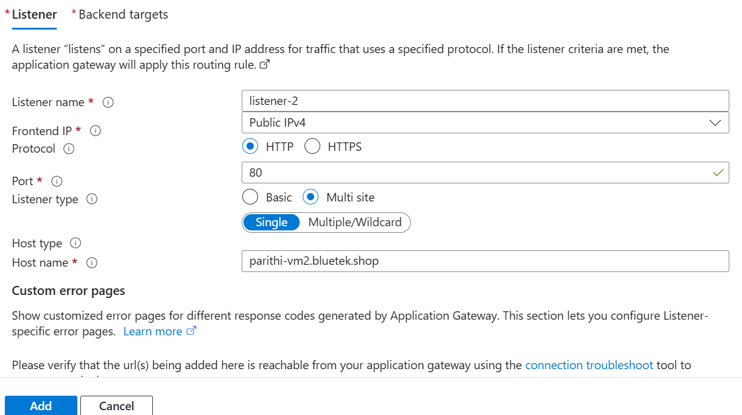

Step 9 – Configure Routing Rules
- Go to Rules → Add rule
  - Name: rule-site1
  - Listener: listener-site1
  - Backend target: backendpool-vm1 + setting-vm1
  - Save
- Add another rule:
  - Name: rule-site2
  - Listener: listener-site2
  - Backend target: backendpool-vm2 + setting-vm2
  - Save
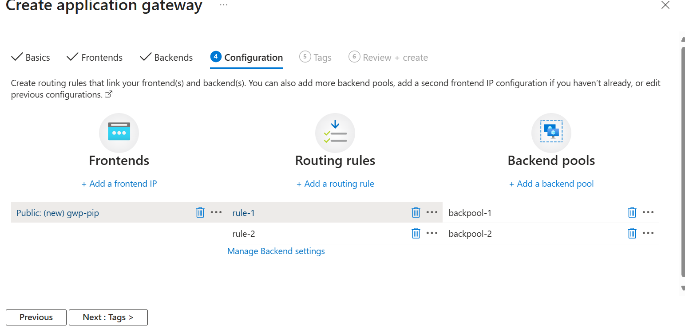

Step 10 – Create DNS Zone
- Go to DNS Zones → Create
  - Name: studentname.com
  - Resource group: studentname-rg
  - Create
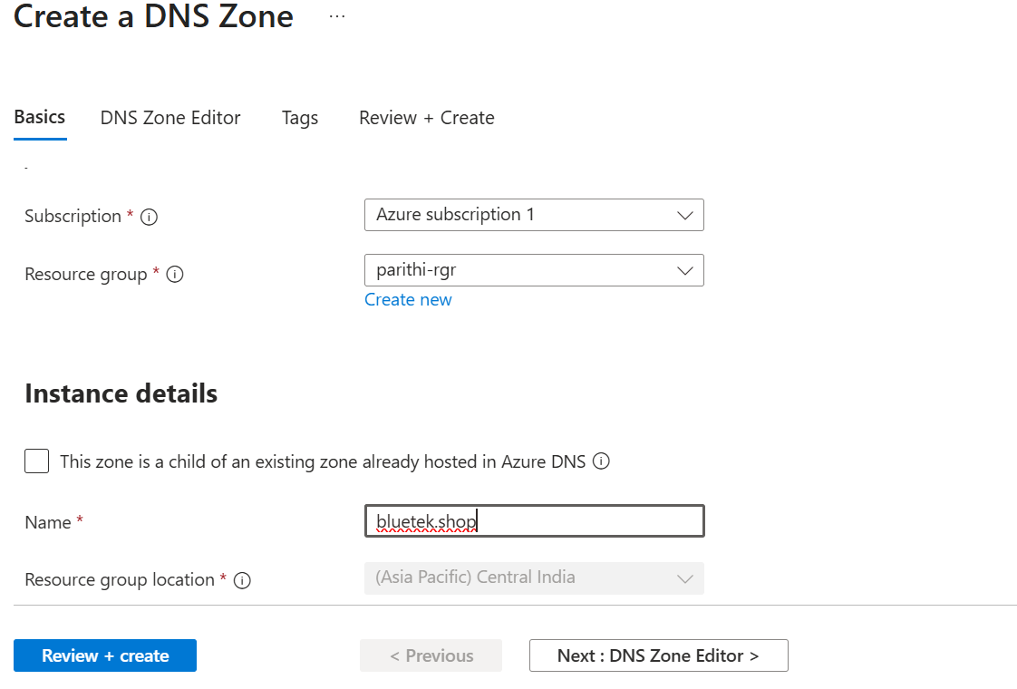

Step 11 – Add DNS Records
- Open DNS Zone → + Record set
  - Name: site1
  - Type: A
  - IP address: Public IP of studentname-appgw-pip
  - Save
- Add another record:
  - Name: site2
  - Type: A
  - IP address: Public IP of studentname-appgw-pip
  - Save
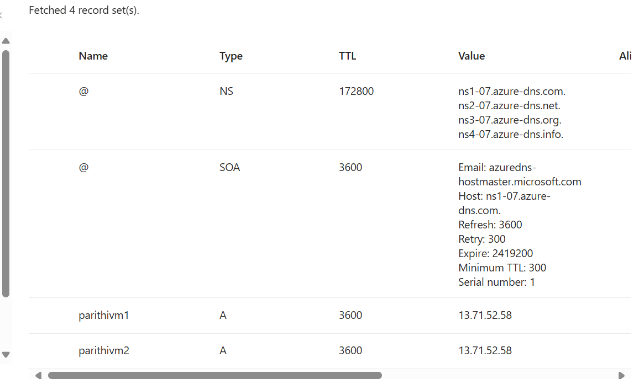

Step 12 – Test in Browser
- Open: http://site1.studentname.com → shows Website 1
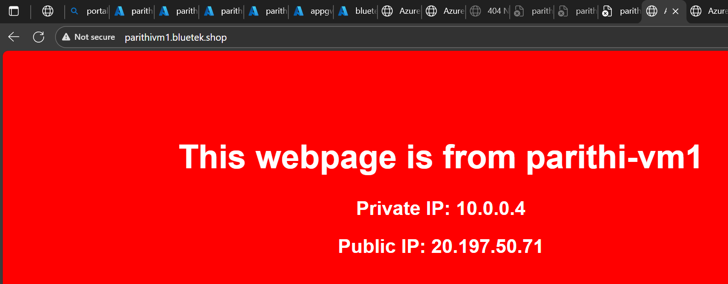
- Open: http://site2.studentname.com → shows Website 2
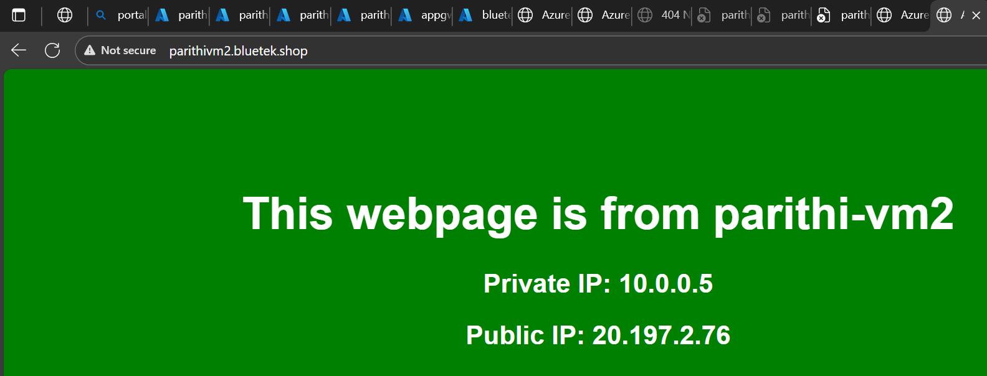

✅ You now have:
- Resource group: studentname-rg
- 2 Linux VMs (studentname-vm1, studentname-vm2)
- Application Gateway (studentname-appgw) with
  - 2 listeners, 2 backend pools, 2 backend settings, 2 rules
- DNS Zone (studentname.com) with records for both sites

